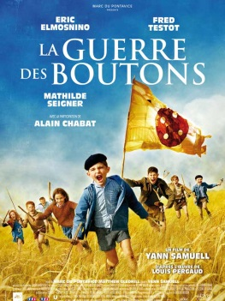
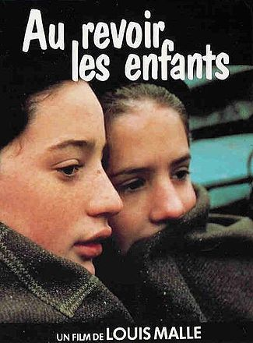
La Guerre des Boutons et Au Revoir les Enfants
Formal Project (30 points)
In this project, you will describe your favorite character from « La Guerre des Boutons » or « Au Revoir les Enfants ». You will also choose a scene that illustrates your character’s personality and analyze it. Your analysis should describe the technical components of the clip, connect them to the director’s purpose, and explain why that scene depicts well the character you chose.
When you analyze the clip, look at the mise-en-scene, cinematography, sound and editing. Examine the ways in which these aspects of the film serve to convey mood and emotion, reveal character, and/or produce a response from the audience.
When you describe your favorite character, look at their personality, at their physical appearance, but also at their relationships with other characters of the story.
Requirements
- Indicate the name of the character chosen
- Indicate the point in the film where the scene is located, ex: [00 : 38 : 44] – [00 : 41 : 01]
- Write at least 400 words
- Give a title to your analysis
- Type your essay and print it out
- Have a short introductory and a short concluding paragraph
- Make sure you have a thesis statement in your introduction
You will be graded on:
- Grammar
- Vocabulary
- Content, Development, and Organization
- Investment and Creativity
Remember that because you are in an advanced class, you should be taking risks when you write and use more complex structures than when you were in French 1 or French 2. Some of the more complex grammar we have been studying this year includes relative pronouns and present participles. Some of the complex grammar from last year includes the use of subjunctive tense and future tense. Try your best to incorporate those elements into your writing!
DUE DATE: MARCH 5TH AT THE BEGINNING OF CLASS
On that day, you will show the chosen scene to the class and briefly talk about your favorite character. (not graded)
Standards:4FL-D2. Experience, discuss and analyze expressive products of the culture including selections from various literary genres and the visual arts
5FL-E1. Present reports in the target language orally and/or in writing on topics being studied in other classes
1FL-P4. Identify and comprehend cultural nuances, including humor, in written and spoken language
1FL-D3. Write analyses of works, noting stylistic conventions and cultural nuances

