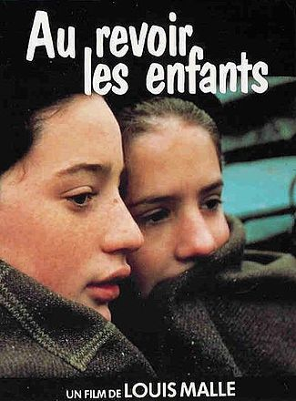
Au Revoir les Enfants
Write a short article to summarize the film and give your opinion. You can use the space below or create a new document. Due on Tuesday 1/20.

Résumé: (at least 150 words)

Critique: (at least 50 words)

