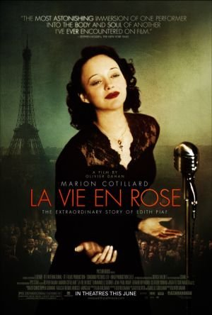
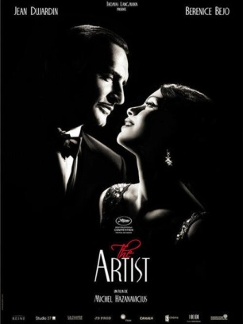
Describing the Life of an Artist
Formal project
This semester, we watched “The Artist” and “La Vie en Rose”. Both movies depict the lives of artists. Write an essay to compare and contrast how the lives of the two artists (George Valentin and Edith Piaf) are portrayed in these movies.

Requirements:
- 5 paragraphs (introduction, 3 body paragraphs, conclusion)
- At least 500 words
- Typed, double spaced
- Have a clear and effective thesis statement
- Have a clear and effective topic sentence in each paragraphs
- Use specific examples from the movies

Don’t forget to:
- Use transition words to make your writing flow
- Check your spelling and grammar
- Connect the technical components of the clip to the director’s purpose
- Organize your essay
- Use a range of vocabulary
- Use the relative pronouns (que/qui; ce que/ce qui) to form more complex sentences
- Use the French grammar you have learned throughout the past years in this essay

Attempts to use more complex structures (and not just simple sentences) will be rewarded!

Deadlines:
- Draft due on Thursday, October 23rd at the end of class (10 points)

- Final essay due on Friday, October 31st at the beginning of class (40 points)

