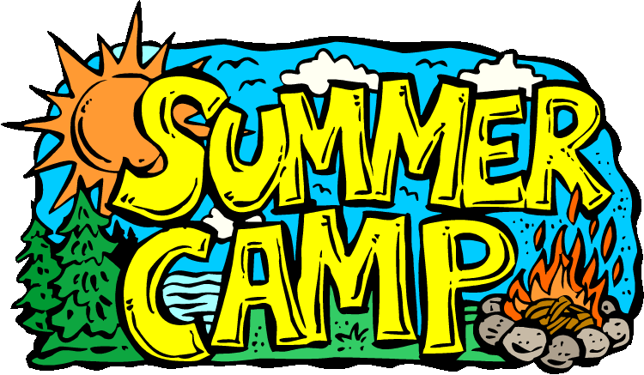
Middle School French
Formal Project #1

Part 1 (in groups)
You are applying to be a junior counselor at a camp in France where French teenagers practice speaking English. With a partner, play the roles of the American student and the French camp official.
If we have one group of 3 in the class: One camp official and 2 students interviewing at the same time, answering the same questions.
- Both: Greet each other in French, introduce yourselves, and ask each other how things are going.
- Camp official: Tell the student one thing you like to do. Ask the student what he/she likes to do
- American student: tell the camp official at least 5 activities you like to do (appropriate for camp) and how much you like to do each one.
- Camp official: ask the student what he/she does not like to do
- American student: tell the camp official at least 2 activities you don’t like to do
- Camp official: ask the student if he or she likes to listen to music
- Say that you do like to listen to music and specify what kinds
- Both: Thank each other and say goodbye.
Part 2 (individually)
Imagine that you have just interviewed with the camp official for the job of junior counselor. Write a letter to the camp director, Mr. Desrosiers, restating what you said in your interview. Begin your letter with Monsieur, and at the end thank him and sign your letter. Write at least 12 sentences. Use formal language. Check your spelling, sentence structure, and grammar.
DUE DATES
Draft of part 1 due at the end of class on Friday, September 30th
Draft of part 2 due at the end of class on Tuesday, October 4th
Final version of the project due on Tuesday, October 11th.
On that day, you will turn in the letter (typed+printed) and present your dialogue to the class. Memorize your lines so that you don’t have to read as you present.

