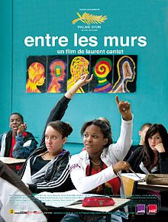
SEMESTER 1 FINAL PROJECT
In this project, you will pretend that you just directed a movie inspired by “Entre les Murs”.
To present your movie to the public, you will create the following:

Part1: A movie description (fiche de film) including:
- The title
- The actors
- The year of production
- The movie length
- A summary (at least 10 sentences)
- An explanation of the similarities and differences with “Entre les Murs” (at least 10 sentences)
- At least 3 short critiques that you invent ( at least 10 sentences total)
You can choose the format (poster, booklet, news article etc.), but it has to be clear and well-organized.

Part 2: A trailer (une bande annonce) lasting at least 45 seconds and including:
- At least one reference to « Entre les Murs »
- At least one reference to something you learned about French education
- Yourself speaking French and French only

PROJECT DUE DECEMBER 11TH IN CLASS
On that day, you will present your project to the class. You should be able to talk about your project without reading your notes. Also, be ready to answer a few questions about the final product or the making process.

Grading (see rubrics)
Fiche de film: 30 points (formal)
Bande annonce: 12 points (formal)
Presentation: 8 points (formal)
Total: 50 points

